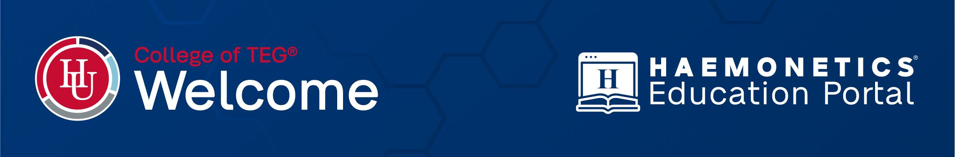
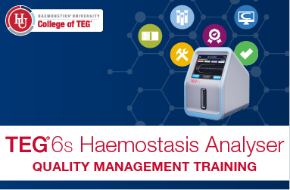
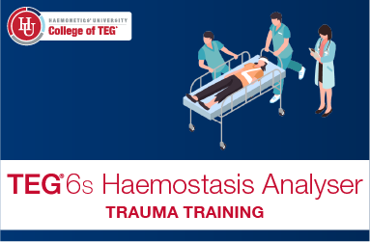
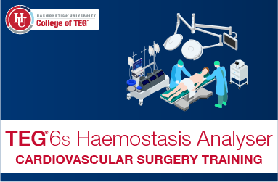
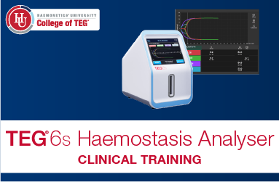
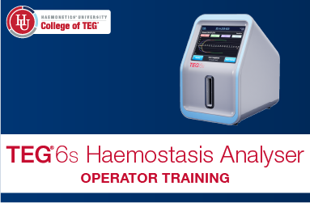
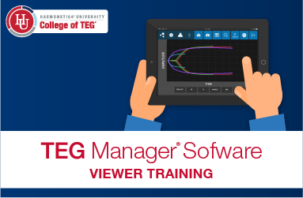
Quality Management Training
Help ensure the reliability of patient results through quality control and exploration of potential risks in all phases of TEG testing.
TEG Manager® Software Training
Learn how this web-based software solution provides access to clinical results and management of users and devices.
Trauma Training
Explore trauma-related haemostatic challenges and how the TEG 6s analyser results can help. Apply this knowledge in interactive clinical scenarios.
Cardiovascular Surgery Training
Explore the causes of haemostatic imbalance and how the TEG 6s analyser results can inform treatment decisions. Apply this knowledge in interactive clinical scenarios.
Clinical Training
Learn to effectively read TEG 6s results to make more informed clinical decisions. Pinpointing haemostatic disturbances better equips you to monitor and maintain the haemostatic balance of your patients.
Operator Training
Learn about the TEG 6s analyser and operational best practices to enable you to confidently and competently generate results, providing complete and accurate haemostasis profiles with ease.
We are pleased to welcome you to the Haemonetics Education Portal
to access our comprehensive suite of College of TEG® eLearning.



Use the link or scan the QR code below to access the Haemonetics Education Portal:

https://educationportal.haemonetics.com

For initial setup of your own individual account, you will require your hospital’s Education Portal Passkey – see below:

Education Portal Passkey

Passkey: teg1225

Course Selection

- Create your account and once logged in to the Education Portal, select the course that you wish to complete.
- Courses take approximately 30-45 minutes to complete.
- Your progress within each course is tracked. If you close a course without completing it, you will be given the option to resume from the last page you viewed.
- A Certificate of Completion is available at the end of each assessment and can be retrieved from your own Education Portal dashboard.
- Upon completion, you will be returned to the Education Portal to complete additional courses if you wish or review other training materials.

Need Help?

If you have any questions or need further assistance, please reach out to your local Haemonetics representative or email digital@haemonetics.com

Thank you for your interest in our College of TEG® eLearning training program. Please follow the instructions below to access.

